Project 6 – Useful Commands
Table of Contents
Access Windows Files from Linux Container 1
Access Linux Files from Windows 1
Launch Windows files and programs from WSL 2
GUI Based Linux Applications with native Windows interactions 2
Building the Image 2
Execute/Run the Image 2

Access Windows Files from Linux Container
- Navigate to ‘/mnt’ and then your Windows drive letter

  - ‘cd /mnt/c’

Access Linux Files from Windows
- View your linux files by navigating to:

  - ‘\\wsl/localhost\’ or clicking on the ‘Linux” Icon

  - 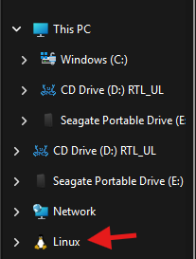

Launch Windows files and programs from WSL
- While using WSL you can run your windows executables directly from bash. Try running ‘powershell.exe /c start.’ To open file explorer in your current folder.

GUI Based Linux Applications with native Windows interactions

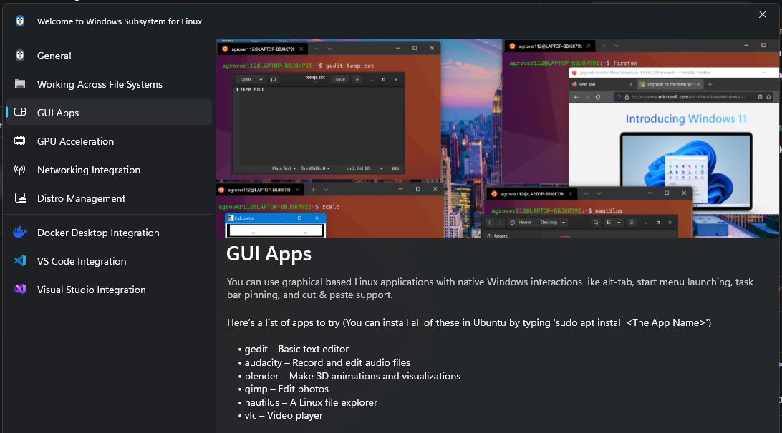

Building the Image
CODE = ORANGE
Description = BLUE
cd "C:\Users\bboyk\OneDrive\Projects\Projects-git\project-6-secure-containers\app"
- Changing to the local working directory.
docker build -t project6-api:local .
- Builds the container image
- The -t flag tags your image with a name.
- And the . lets Docker know where it can find the Dockerfile.

Execute/Run the Image
docker run --rm -p 8080:8080 -e APP_SECRET=local-demo-secret project6-api:local
- Runs the Container Image

Test the Container using PowerShell
curl http://localhost:8080/health
curl http://localhost:8080/info

